Example from «opparbeiding» (MILKYS+Lange tidsserier - analyser 2018_2.xlsx)

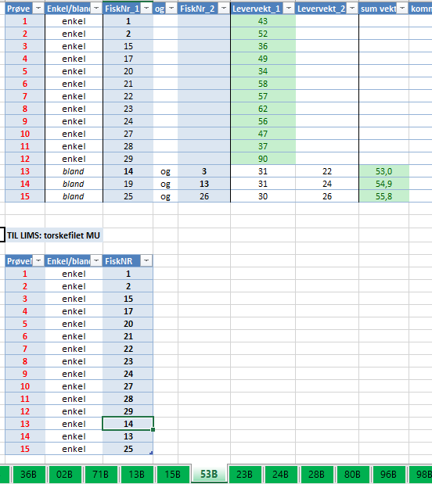

Same station, result of generate_04_fish_station() (22_ICES_submission.Rmd) (sorted by SAMPLE_NO_muscle)

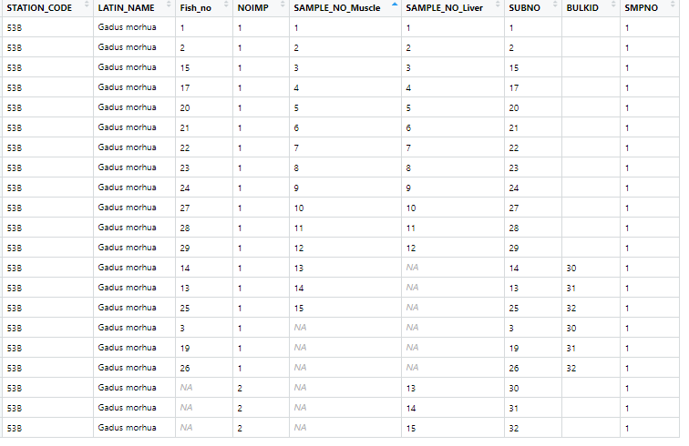

1. Fish_no = 1: Used (unpooled) for muscle sample 1 and liver sample 1
2. SAMPLE_NO_Liver = 13 : Pooled sample from two fish (therefore NOIMP = 2), given SUBNO = 30. Two lines have BULKID = 30, Fish_no 14 and 3. (Note that 3 has no muscle sample, but it has length so this will be given later.)

Note that BULKID is only given for individual fish, so if BULKID is given, NOIMP must be 1